AVIZAT,

FISA DE VERIFICARE A INDEPLINIRII STANDARDELOR MINIMALE NECESARE SI OBLIGATORII PENTRU CONFERIREA TITLURILOR DIDACTICE DIN INVATAMANTUL SUPERIOR SI A GRADELOR PROFESIONALE DE CERCETARE-DEZVOLTARE

Comisia 20 MEDICINA

COZMIN MIHAI

Tabelul nr.1 Standarde minimale conform MENCS nr. 6129/20.12.2016

Titlul | Nr. Articole ISI Autor principal | Nr. Articole ISI Coautor | Index  Hirsch Web of Science | (ISI) Factor cumulat de impact autor principal (FCIAP)
Conferentiar/CSII | 6 | 3 | 4 | 6

- Numar acticole ISI AUTOR PRINCIPAL – 15 articole (2 articole- primul autor, 3 articole- ultimul autor, 3 articole – autor corespondent și 7 articole - toti autorii au contributii egale cu primul autor)

- Mihai Cozmin, Ionut Iulian Lungu, Cristian Gutu, Alin Stefanache, Letitia Doina Duceac, Bogdan Dorin soltuzu, Daniela Damir, Gabriela Calin, Elenea Roxana Bogdan Goroftei, Carmen Grierosu, Monica Boev, Turmeric: from spice to cure. A review of the anti-cancer, radioprotective and anti-inflammatory effects of turmeric sourced compounds Frontiers in Nutrion, vol. 11, 2024., - (autor principal – toti autorii au contributii egale cu primul autor) Q2 FI=4
DOI: 10.3389/fnut.2024.1399888
WOS:001242884800001
https://www.frontiersin.org/articles/10.3389/fnut.2024.1399888/full

- Elena Costescu, Tudor Ciuhodaru, Gabriela Calin, Cozmin Mihai, Carmen Grierosu, Daniela Liliana Damir, Non-invasive neuromodulatory therapies applied in trigeminal neuralgia, Balneo and PRM Research Journal. 2024;15(2):705, (autor principal – toti autorii au contributii egale cu primul autor) Q4, FI=0.7
DOI: 10.12680/balneo.2024.705
http://bioclima.ro/Balneo705.pdf

- Gabriela Călin, Elena Costescu, Daniela Liliana Damir, Cozmin Mihai, Carmen Grierosu, Tudor Ciuhodaru, Pluridisciplinary approaches in global postural rehabilitation, Balneo and PRM Research Journal. 2024;15(2):711, (autor principal – toti autorii au contributii egale cu primul autor) Q4, FI=0.7
DOI: 10.12680/balneo.2024.711
http://bioclima.ro/Balneo711.pdf

- Carmen Grierosu, Cozmin Mihai, Ionut Iulian Lungu, Gabriela Calin, Alina Stefanache, Mihaela Papusa Vasiliu, Gabriela Liliana Haliţchi, Daniela Ivona Tomiţa, Diana Mihaela Gheban, Codrin Paul Fuioaga, Carmen Stadoleanu, Stress-induced variability in local anesthesia response: exploring implications for dental anesthetic management, Romanian Journal of Oral Rehabilitation, Vol. 16, No.1 January-March 2024-, pp. 608-617- (autor principal – toti autorii au contributii egale cu primul autor) Q4 FI=0,6
DOI : 10.6261/RJOR.2024.1.16.59
WOS:001212387500050
https://rjor.ro/wp-content/uploads/2024/04/STRESS-INDUCED-VARIABILITY-IN-LOCAL-ANESTHESIA-RESPONSE-EXPLORING-IMPLICATIONS-FOR-DENTAL-ANESTHETIC-MANAGEMENT.pdf

- Cosimo Caltabellotta, Carmen Stadoleanu, Gabriela Calin, Ionut Iulian Lungu, Alexandru Armenia, Mihaela Vasiliu, Diana Gheban, Catalina Girbea, Constanta Mocanu, Alina Stefanache, Cozmin Mihai, Carmen Grierosu, NOBLE METAL CEMENTS: BALANCING ADVANTAGES AND CONSIDERATIONS IN DENTISTRY, Romanian Journal of Oral Rehabilitation, Vol. 16, No.1 January-March 2024, PP. 177-187 –ULTIM AUTOR Q4 FI=0,6
DOI : 10.6261/RJOR.2024.1.16.15
WOS:001212387500014
https://rjor.ro/wp-content/uploads/2024/04/NOBLE-METAL-CEMENTS-BALANCING-ADVANTAGES-AND-CONSIDERATIONS-IN-DENTISTRY.pdf

- Alina Stefanache, Cozmin Mihai, Ionut Iulian Lungu, Gabriela Calin, Cristian Mihalache, Deleu Grigorii, Budirinca Maria Alexandra, Catalina Girbia, Oana Cucoveica, Carmen Stadoleanu, Carmen Grierosu, Evolution and applications of radiopharmaceuticals in nuclear dentistry: a comprehensive overview, Romanian Journal of Oral Rehabilitation, Vol. 16, No.1 January-March 2024, pp.628 – 636 - (autor principal – toti autorii au contributii egale cu primul autor) Q4 FI=0,6
DOI : 10.6261/RJOR.2024.1.16.61
WOS:001212387500052
https://rjor.ro/wp-content/uploads/2024/04/EVOLUTION-AND-APPLICATIONS-OF-RADIOPHARMACEUTICALS-IN-NUCLEAR-DENTISTRY-A-COMPREHENSIVE-OVERVIEW.pdf

- Branisteanu, DE ; Porumb-Andrese, E ; Starica, A; Munteanu, AC; Toader, MP; Zemba, M; Porumb, V ; Cozmin, M ; Moraru, AD ; Nicolescu, AC; Branisteanu, DC, Differences and Similarities in Epidemiology and Risk Factors for Cutaneous and Uveal Melanoma, Volume 59, Issue 5, 2023, DOI10.3390/medicina59050943, MEDICINA-LITHUANIA, FI=2.4 – toti autorii au contributii egale – 3 CITARI, https://www.mdpi.com/1648-9144/59/5/943

- Branisteanu, DE; Cozmin, M; Porumb-Andrese, E; Branisteanu, D; Toader, MP ; Iosep, D; Sinigur, D; Branisteanu, CI; Branisteanu, G ; Porumb, V ; Pînzariu, AC; Baila, SL; Nicolescu, AC, Sentinel Lymph Node Biopsy in Cutaneous Melanoma, a Clinical Point of View, Volume 58, Issue 11, 2022, DOI10.3390/medicina58111589, Article Number 1589, MEDICINA-LITHUANIA, FI=2.6 – toti autorii au contributii egale – 1 CITARE

- Gina I. Constandache, Oana Munteanu, Andra Șălaru, Bianca Oroian, Cozmin Mihai An overview of the treatment of eating disorders in adults and adolescents: pharmacology and psychotherapy. Advances in Psychiatry&Neurology, Postep Psychiatr Neurol. , 32(1): 40–48. Published online 2023 May 8, doi: 10.5114/ppn.2023.127237
PMCID: PMC10243293PMID: 37287736 (2023). FI = 0.7, - ultim autor.
https://www.ncbi.nlm.nih.gov/pmc/articles/PMC10243293/

- Cozmin, M ; Cigu, AT; Stefanescu, A; Stoicescu, H; Stafie, L; Vasiliu, M ; Stadoleanu, C, Patient- stomatologist relation within the pandemic context, Volume 25, Issue 3, Page250-258, 2021, INTERNATIONAL JOURNAL OF MEDICAL DENTISTRY, FI=0 – PRIMUL AUTOR – 0 CITARI

- Costandache, GI; Oroian, BA; Salaru, AP; Ionescu, PF; Mihai, C, The cognitive consequences of the COVID-19 infection and behavioral variant frontotemporal dementia: Is there a link?, Volume 66, Page S791-S791, Supplement 1, Special Issue SIMeeting, DOI10.1192/j.eurpsy.2023.1671, 2023, EUROPEAN PSYCHIATRY, FI=7.2, ULTIM AUTOR - 0 CITARI

- Cozmin Mihai, Roxana Chiriță, Viorel Robu, Ilinca Untu, Andreea Silvana Szalontay, (2017). Predicting Suicide Risk Among Male Offenders: The role of severe personality disorders. Revista de cercetare și intervenție socială, vol 57, pp.28-50 (prim autor). IF=0.83

- Ana Maria Ciubară, Roxana Chiriță, Lucian Ștefan Burlea, Valeriu Vasile Lupu, Cozmin Mihai, Ștefana Maria Moisă, Ilinca Untu, (2016). Psychosocial Particularities Of Violent Acts In Pesronality Disorders. Revista de cercetare și intervenție socială, vol. 52, pp. 265-272 (autor corespondent). IF=0.38

- Maria Raluca Radu, Roxana Chiriță, Cozmin Mihai, Lucian Constantin Paziuc, (2018). Depression and Deficiences of Intimacy and Comunity Integration in Older Patients, Revista de cercetare si interventie sociala, vol.61, pp.32-43 (autor corespondent). IF=1.07

- Roxana Bliuc, Andrei Ioan Costea, Cozmin Mihai, Sorin Ioan Stratulat, (2018). The Role of Family in Medical Rehabilitation. Revista de cercetare și intervenție socială, vol. 60, pp.51-64, (autor corespondent) IF=1.07

FI (AUTOR PRINCIPAL)= 5(art.1) +1.5(art.2) + 1.5(art.3) + 0,6 (art.4)+0.6 (art.5) + 0.6 (art.6)+2.6 (art.7)+2.6 (art.8)+0.2(art.9)+0.06(art.10)+7.6(art.11) +0(art.12) +0(art.13) +0(art.14) +0(art.15)= 22.96

Nr. Art. | 1 | 2 | 3 | 4 | 5 | 6 | 7 | 8 | 9 | 10 | 11 | 12 | 13 | 14 | 15 | Total FI
Fi. Articol | 4 | 0.7 | 0.7 | 0.6 | 0.6 | 0.6 | 2.4 | 2.6 | 0.7 | 0 | 7.2 | 0.83 | 0.38 | 1.07 | 1.07 | 23.45

- Numar Articole ISI Coautor

- Andor, CT ; Mihai, C; Cucoveica, O; Stadoleanu, C ; IvonaTomita, D; Vasiliu, MP , Costescu, E; Apintiliesei, A ; Girbea, C; Morarasu, CS, Functional and psychorehabilitation of the of the stomatognatic sistem 's disorders- a non invasive treatment approach, Volume 15, Issue 1, Page 130-137, 2023, ROMANIAN JOURNAL OF ORAL REHABILITATION, –co-autor
https://rjor.ro/wp-content/uploads/2023/04/FUNCTIONAL-AND-PSYCHOREHABILITATION-OF-THE-OF-THE-STOMATOGNATIC-SISTEM-%E2%80%98S-DISORDERS-A-NON-INVASIVE-TREATMENT-APPROACH-1.pdf
http://rjor.ro/steroid-resistant-nephrotic-syndrome-in-children-a-continuum-of-challenges/
- Paziuc, LC; Marginean, R; Cozmin Mihai; Chirita, R, Rethinking Psychiatric Care: Assessing the Impact of a Community Intervention Program, Revista de cercetare si interventie sociala, 2018, 63, pp.359-370 – co-autor, FI=0,
- Cigu, AT; Mihai, C; Cozmin Mihai ; Morarasu, C, Medical reasoning in dental practice, ROMANIAN JOURNAL OF ORAL REHABILITATION, 2022, 14 (4) , pp.14-25 – co-autor,

C). Index Hirsh Web of Science – 4

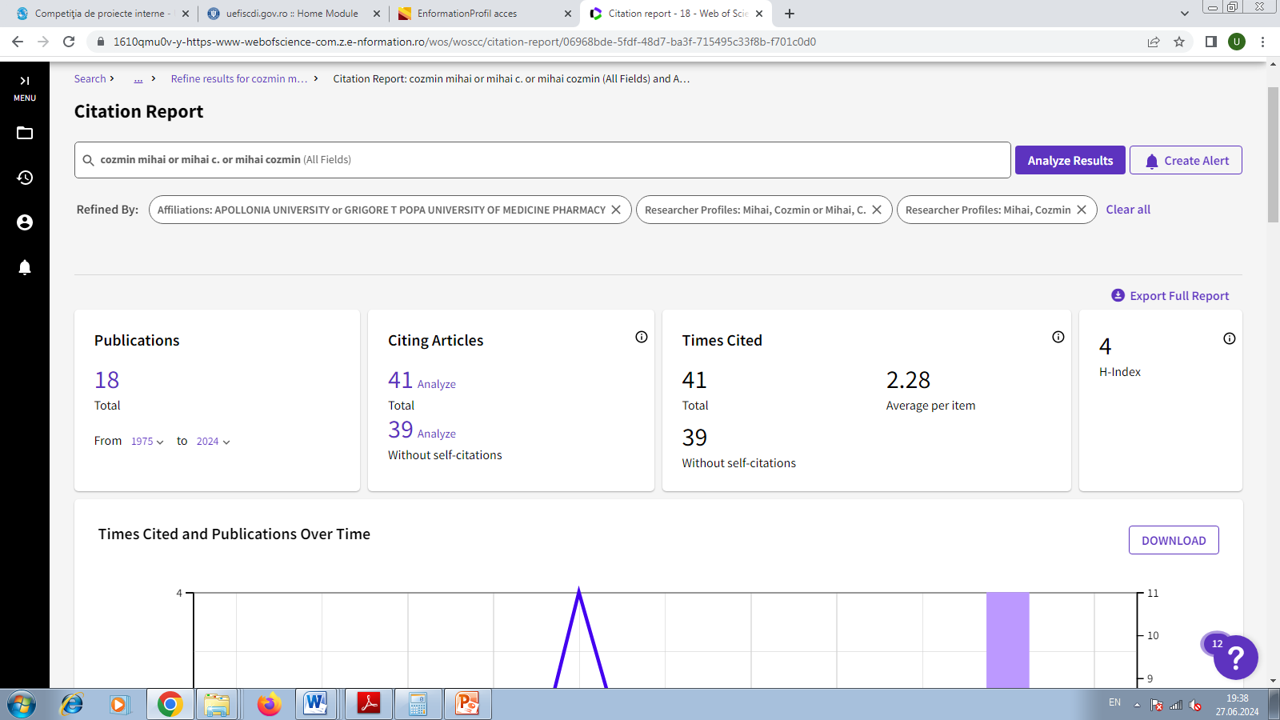
Gradul de îndeplinire a standardelor minimale conform MENCS nr. 6129/20.12.2016
Profesor universitar / CSI/Abilitare
Categorie | Criteriu | Grad de îndeplinire
Nr. articole ISI Autor principal | 6 | 15 articole (2 articole- primul autor, 3 articole- ultimul autor, 3 articole – autor corespondent și 7 articole - toti autorii au contributii egale cu primul autor)
Nr. articole ISI Coautor | 3 | 3
Index Hirsh Web of Science | 4 | 4
(ISI) Factor cumulat de impact autor principal (FCIAP) | 6 | 23.45

18.06.2024 Sef. lucr. dr. COZMIN MIHAI

